Prevention of wrong volume type selection

Cloud watch 🡪 event creation 🡪 lambda function creation (gp3 volume) 🡪 creating gp2 volume by mistake 🡪 gp2 volume converted in to gp3

* If a company uses gp3 volume and an employee by mistake creates a volume of gp2 type
* To prevent this, we have automated the process of converting volume type
* With this process we don’t have to delete the volume and recreate it again, it automatically can the volume type.

This is the rule we have created in events

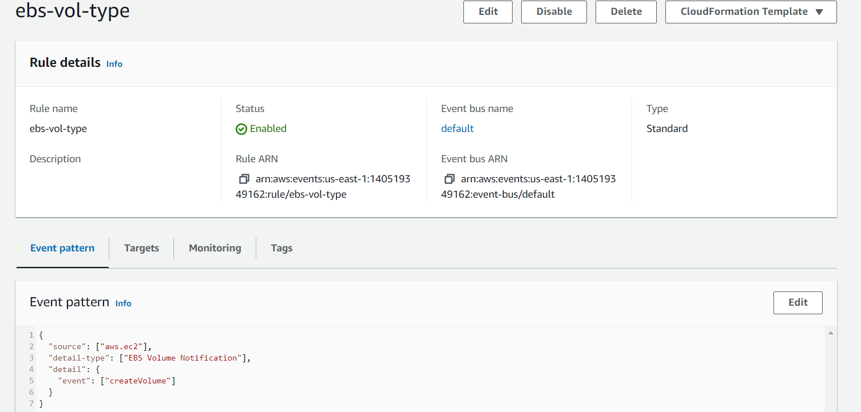

Lambda function for automation

